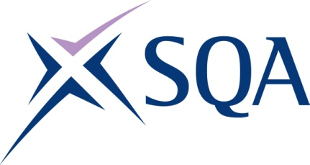
GM67 23 | SVQ Thermal Insulation (Construction) at SCQF level 6

To attain the qualification candidates must complete 8 units in total. This comprises:

- 7 mandatory units
- 1 optional units

Please note the table below shows the SSC identification codes listed alongside the corresponding SQA unit codes. It is important that the SQA unit codes are used in all your recording documentation and when your results are communicated to SQA.

Mandatory units: Candidates must complete all units from this group
SQA code | SSC code | Title | SCQF level | SCQF credits
HL7P 04 | COSVR209v2 | Confirm Work Activities and Resources for the Work | 6 | 18
HL7Y 04 | COSVR210v3 | Develop and Maintain Good Working Relationships | 8 | 8
HL7N 04 | COSVR211v2 | Confirm the Occupational Method of Work | 6 | 14
HL6L 04 | COSVR216v2 | Confirm Work Meets Quality Standards | 7 | 9
HL7L 04 | COSVR586v1 | Resolve Indeterminate Situations | 7 | 19
HL7R 04 | COSVR641v2 | Conform to General Workplace Health, Safety and Welfare | 6 | 12
Plus one of the following optional routes
PLUS ONE OF THE FOLLOWING OPTIONAL ROUTESFabricate Protection option route (Total of eight units required)
HL7G 04 | COSVR654v1 | Fabricate Joints in Thermal Insulation Protection using Sheet Metal | 6 | 45
Plus optional (one unit from the following required)
HL7H 04 | COSVR323v2 | Fabricate Sheet Metal Insulation Protection from Existing Templates | 5 | 39
HL7J 04 | COSVR324v2 | Fit Sheet Metal Insulation Protection | 5 | 39

SQA code | SSC code | Title | SCQF level | SCQF credits
Apply Insulation option route (Total of eight units required)
HL7E 04 | COSVR655v1 | Apply Insulation and Finishes to Complicated Surfaces | 6 | 35
Plus optional (one unit from the following required)
HL7F 04 | COSVR322v2 | Apply Insulation and Finishes to Cylindrical and Flat Surfaces | 5 | 64
HL7K 04 | COSVR656v1 | Remove and Replace Thermal Insulation for Maintenance or Inspection | 6 | 32

